|  |
| --- |
| s |
| VEHICLE INSURANCE |
| Project Documentation of DISM (Semester II) |

**our team members**

**our team members**

* MEHWISH TARIQ student 1114548
* TEHREEM SULTANA Student 1107670

* ESHA JAWAID student 1106968
* MOHAMMAD AFFAN KHAN student 1088697

**Faculty** = Miss Aatika Liaquat

**Batch Code** = 1804B1

**Curriculum**= 6673

**Semester**= HDSE I

**Table of Contents: -**

1. Acknowledgment....................................................................................................... 4
2. Abstract………………………………………………………………………………………………………………… 4
3. Declaration…………………………………………………………………………………………………………… 5
4. Certificate…………………………………………………………………………………………………………….. 6
5. **CHAPTER I :** INTRODUCTION…………………………………………………………………………………. 8
6. Problem Statement………………………………………………………………………………… 8
7. Need of Project……………………………………………………………………………………… 10
8. **CHAPTER II** : PROJECT MAKING & BACKGROUNDS………………………………………………. 11
9. Project Duration………………………………………………………………………………………. 12
10. Task Sheet……………………………………………………………………………………………….. 13
11. **CHAPTER III** : SOFTWARE & HARDWARE REQUIREMENTS…………………………………… 14
12. Hardware Requirements……………………………………………………………………………. 15
13. Software Requirements……………………………………………………………………………… 15
14. **CHAPTER IV** : WORKFLOW SUBMISSION CHECKLIST…………………………………………… 16
15. Workflow Submission Checklist…………………………………………………………………….. 17
16. Screenshots…………………………………………………………………………………………………… 18
17. Application Map…………………………………………………………………………………………….20
18. **CHAPTER V**: CONCLUSION………………………………………………………………………………….. 20
19. Remarks………………………………………………………………………………………………………… 22
20. Application……………………………………………………………………………………………………. 22
21. Problem Faced……………………………………………………………………………………………… 22
22. Future Enhancement……………………………………………………………………………………… 22

1- Acknowledgement:

We would want to appreciate and thank all of those people who helped us during this journey of completing our project. Without everyone’s support, we could not have accomplished our work.

We express our sincere gratitude to our faculty “--Miss Aatika Liaquat--" and our coordinator for their amazing support and guidance, continuous encouragement and supervision throughout the course of the present work. It’s of no doubt that we have been very fortunate to work under such a supportive and cooperative teacher/coordinator

And last but not the least we are extremely grateful to the whole faculty and administration of Aptech, for providing us all the facilities that were mandatory, without which this project could not be a success.

2- Abstract:

The capstone project **“VEHICLE INSURANCE “**, I have been working on is about the development of a Website.

It’s made using Visual Studio MVC and MySQL Database Mainly. This application has as purpose to help my client in managing his work; as for any Owners well as their Employees

as well as Customers.

The VEHICLE INSURANCE will offer several features such as managing Employee, to have a view/maintain Purchase Records of their vehicle insurance. also making the client and application easy interaction. Also provides proper crystal reporting .

The report reflects the work done and its progress and describes in more details of this project’s stages.

The project’s first stage is the requirements and specification stage. During this stage,

the client’s needs are gathered and proceeded; for VEHICLE INSURANCE, the requirements were

expressed explicitly.

Once this phase done, comes up the feasibility study where the technical aspect is

tackled. This stage is partially driven by the application’s type to be developed, technology

enablers such as programming language, and database.

After the feasibility study done comes the design and analysis phase with the design of

database entities.

Finally comes the implementation phase with a description of all the necessary tools

used to develop the application.

3- Declaration

We are writing this to declare that all the work which is being written bellow in this Project Report entitled “—**VEHICLE INSURANCE**--” is a veritable record of our own work submitted to the Aptech NN, Karachi, Pakistan during the year 2019 to 2020 in the partial fulfillment of semester III (HDSE) project We also declare that we have not submitted the material being presented in this Project Report for the award of any other degree elsewhere.

Signatures:

MEHWISH TARIQ STUDENT 1107942

TEHREEM SULTANA STUDENT 1098556

ESHA JAWAID STUDENT 1074493

MOHAMMAD AFFAN KHAN STUDENT 1098868

Certificate: -

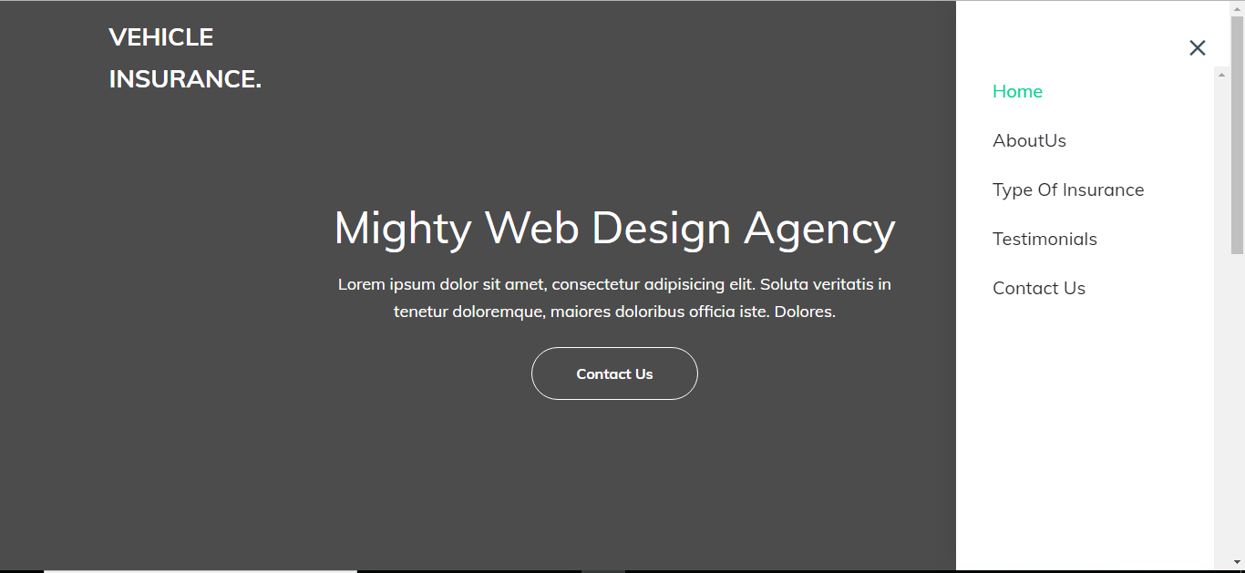

This is to certify that,

Mr./ Ms.

MEHWISH TARIQ

TEHREEM SULTANA

ESHA JAWAID

MOHAMMAD AFFAN KHAN

Has successfully Designed & Developed

VEHICLE INSURANCE

Date of Issue:

**28-OCT -2019**

Date of Submission:

27-NOV-2019

**28th-OCT-2019**

Authorized Signature: **Miss Aatika Liaquat**

INTRODUCTION

Problem Statement: -

**Introduction**

The thirst for learning, upgrading technical skills and applying the concepts in real

life environment at a fast pace is what the industry demands from IT professionals

today. However busy work schedules, far-flung locations, and unavailability of

convenient time-slots pose as major barriers when it comes to applying the concepts

into realism. And hence the need to look out for alternative means of

implementation in the form of laddered approach.

The above truly pose as constraints especially for our students too! With their busy

schedules, it is indeed difficult for our students to keep up with the genuine and

constant need for integrated application which can be seen live especially so in the

field of IT education where technology can change on the spur of a moment. *Well,*

*technology does come to our rescue at such times!!*

Keeping the above in mind and in tune with our constant endeavour to use

Technology in our training model, we at Aptech have thought of revolutionizing the

way our students learn and implement the concepts using tools themselves by

providing a *live and synchronous eProject learning environment!*

**So what is this eProject?**

eProject is a step by step learning environment that closely simulates the classroom

and Lab based learning environment into actual implementation. It is a project

implementation at your fingertips!! An electronic, live juncture on the machine that

allows you to

o Practice step by step i.e. laddered approach.

o Build a larger more robust application.

o Usage of certain utilities in applications designed by user.

o Single program to unified code leading to a complete application.

o Learn implementation of concepts in a phased manner.

o Enhance skills and add value.

o Work on real life projects.

o Give a real life scenario and help to create applications more complicated and

useful.

o Mentoring through email support.

The students at the centre are expected to complete this eProject and send complete

documentation with source code within the time allotted to eProjects Team

Looking forward to a positive response from your end!!

**Objectives of the project**

The Objective of this program is to give a sample project to work on real life

projects. These applications help you build a larger more robust application.

The objective is not to teach you the software’s but to provide you with a real life

scenario and help you create basic applications using the tools.

You can revise the topics before you start with the project.

These programs should be done in the Lab sessions with assistance of the faculty if

required.

It is very essential that a student has a clear understanding of the subject.

Kindly get back to eProjects Team in case of any doubts regarding the

application or its objectives.

**Introduction**

**Problem Statement**

The problem statement is attached separately in a file “VehicleInsuranceManagement.doc”

**Standards plan:**

Every code block must have comments.

The logic of the program needs to be explained. Proper documentation should be

maintained.

Complete Project Report along with synopsis, code and documentation should be

prepared.

**Documentation:**

No project is complete without documentation. In fact, it is one of the most

important activities during the development of a project. The documentation of an

ideal project will be in the form of a project report comprising of the following

documents:

Certificate of Completion.

Table of Contents.

Problem Definition.

Customer Requirement Specification.

Project Plan.

E-R Diagrams.

Algorithms.

GUI Standards Document.

Interface Design Document.

Task Sheet.

Project Review and Monitoring Report.

Unit Testing Check List.

Final Check List.

**Deliverables**

You need to submit the following Deliverables:

1. Documentation of the project.

2. You need to follow all the following points as a part of your

eprojects execution

a) Send us 2 (two) eprojects status mail, each should be after 10

days interval from your eprojects start date. Incase if your project

is less than 30 days then also you need to send 2 (two) status

mails (first status mail between 7-10 days and second 3 days

before the end date of project).

b) The status mail should consist of description with review document

(what's going on the project). Also you can send your doubts / clarification or

any additional inputs required to complete your eproject any time during the

project planning and execution.

c) At the time of project submission also send us the feedback along

with your documentation (soft copy). The Feedback form is

attached with this mail.

**Hardware**

**Hardware/ Software Requirements**

A minimum computer system that will help you access all the tools in the

courses is a Pentium 166 or better

128 Megabytes of RAM or better

**Software**

Visual Studio .Net / ASP

IIS server

.Net Framework

Java Virtual Machine/ J2EE server

Notepad/Java editor

j2sdk1.4.1_02 (or later).

EJB Dev Kit

Java enabled web server

JSP / Servlets Dev. Kit

Need of Project: -

Some of the benefits of Project are as under: -

* Re-enforcement of Skills happens in the experiential learning process.
* A mentor, ensuring that you do not get drifted, constantly guides you.
* It gives you a lot of confidence to face an interview as you have worked on a project. You can explain virtually everything on the subject you have learnt.
* A nice, final, black, hardbound report adds to you credentials and enhances your job prospects.
* Projects is compulsory (Sem-End Project) and is supposed to be done over and above the assignments given in your course books.
* It is advised that if a student follows the projects and submits Assignments, he would definitely have an edge over other students.
* Students need to submit their project report along with working application and source code in the stipulated time.

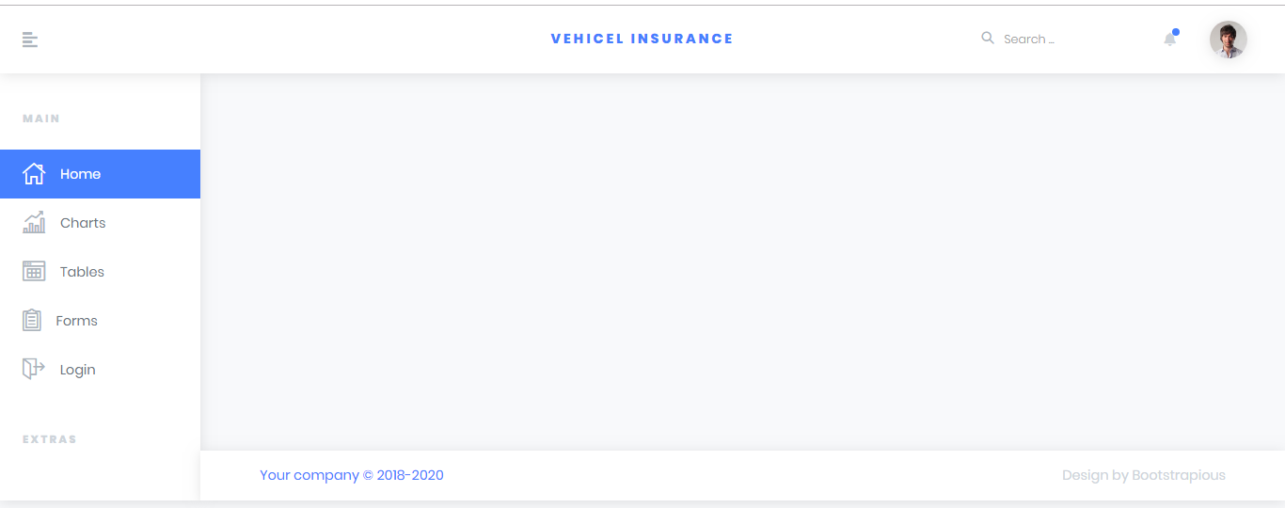

PROJECT MAKING & BACKGROUND

PROJECT DURATION: -

* Analysis- 3 days
* Design – 6 days
* Development –16 days
* Testing – 3 days
* Documentation -1 days

|  |  |  |  |  |
| --- | --- | --- | --- | --- |
| Analysis | Design | Database | Testing | Documentation |

|  |  |  |  |  |  |  |  |  |  |  |  |  |  |  |  |  |  |  |  |  |  |  |  |  |  |  |  |  |  |
| --- | --- | --- | --- | --- | --- | --- | --- | --- | --- | --- | --- | --- | --- | --- | --- | --- | --- | --- | --- | --- | --- | --- | --- | --- | --- | --- | --- | --- | --- |
| 1 | 2 | 3 | 4 | 5 | 6 | 7 | 8 | 9 | 10 | 11 | 12 | 13 | 14 | 15 | 16 | 17 | 18 | 19 | 20 | 21 | 22 | 23 | 24 | 25 | 26 | 27 | 28 | 29 | 30 |

TASK SHEET

|  |  |  |  |  |  |
| --- | --- | --- | --- | --- | --- |
| **No.** | **Task** | **Actual Start Date** | **Actual Days** | **Team Mate Name** | **Status** |
| 1. | Case Study | 28th OCT 2019 | 3 | MEHWISH TARIQ, TEHREEM SULTANA, ESHA JAWAID, MOHAMMAD AFFAN KHAN. | Completed |
| 2. | UI Designing | 1th NOV 2019 | 6 | MEHWISH TARIQ, | Completed |
| 3. | SCENARIO Making | 7th NOV 2019 | 2 | MEHWISH TARIQ, | Completed |
| 4. | Material Searching | 10ST NOV 2019 | 4 | MEHWISH TARIQ, TEHREEM SULTANA, | Completed |
| 5. | Database Connectivity | 14th NOV 2019 | 12 | MEHWISH TARIQ, TEHREEM SULTANA. | Completed |
| 6. | Documentation | 26 NOV 2019 | 2 | TEHREEM SULTANA. | Completed |

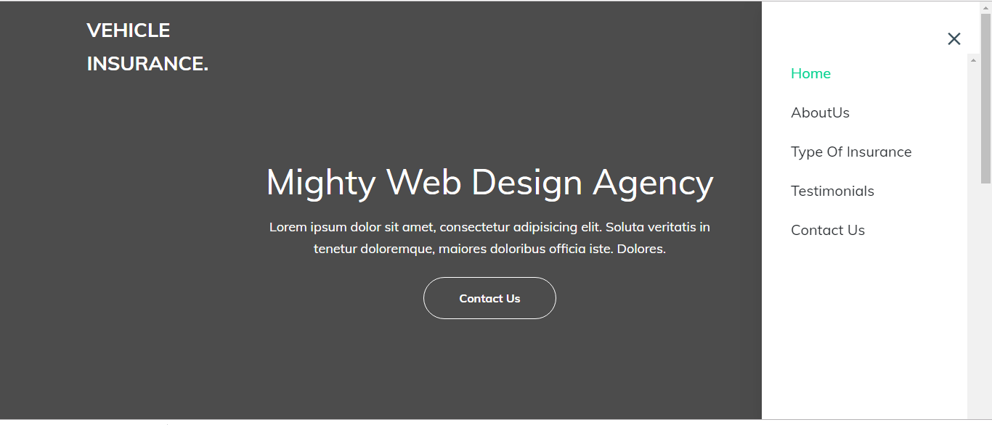

SOFTWARE & HARDWARE REQUIREMENTS

HARDWARE REQUIREMENTS: -

* A minimum computer system that will help you access all the tools in the courses is a Pentium 166 or better.
* 64 Megabytes of RAM or better.

SOFTWARE REQUIREMENTS: -

* Visual Studio 2013,2015,2017,2019
* Browser Google

WORKFLOW SUBMISSION CHECKLIST



## 

WORKFLOW SUBMISSION CHECKLIST:-

|  |  |  |  |
| --- | --- | --- | --- |
| **S.NO** | **LIST OF ITEMS** | **Remarks** | **COMMENTS** |
| 1. | Do All Forms Linked together | **Yes** | By making their objects. |
| 2. | Database Connected | **Yes** | Using  MDF FILE |
| 3. | Page Colors As Per Common Guidelines | **Yes** | Professional Color Combination |
| 4. | All Queries Working | **Yes** | Linked through ADO Data Model |
| 5. | DOCUMENTATION Included | **Yes** | All 3 word documents. |
| 6. | Project Zip File | **Yes** | Created using WinRAR |

SCREENSHOTS: -

# 

# 

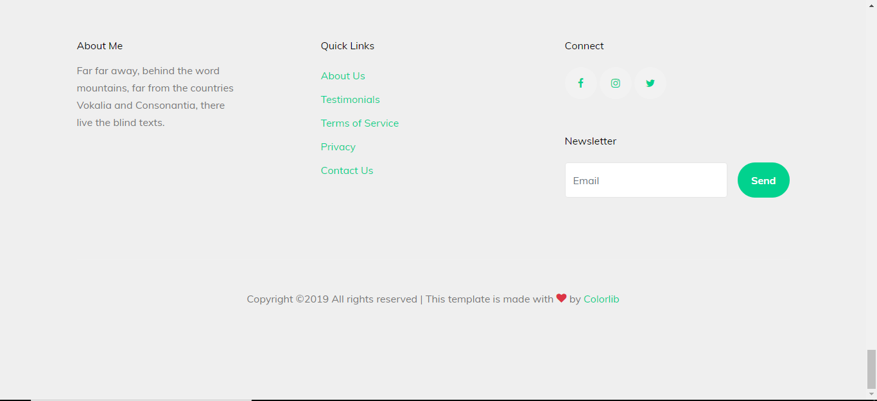

APPLICATION MAP: -

**VEHICLE INSURANCE**

**USER**

**Login**

Contact us

About usffbbbb

Admin

Employee

Records

Employee

Contact

**Client**

Testimonals

Service

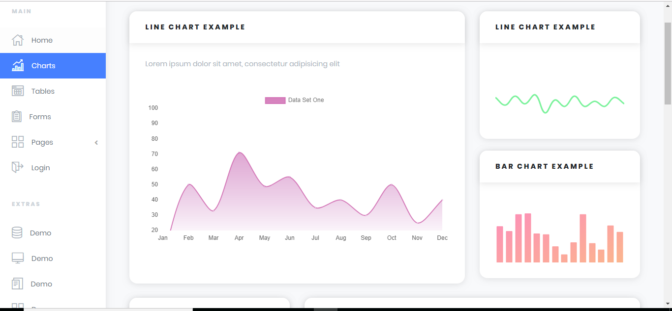

Insurance

CONCLUSION

Remarks: -

It is very nice initiative that has made us work harder on our project and it has polished our skills now we are capable of making a MVC Application all by our own self. We are very thankful to you for giving us an incredible opportunity.

Application: -

It’s an application based on dynamic website . It provides ease for customers to make insurance of their vehicles and even for employee for making their work easy. It help the admin to maintain proper records of customers and employees.

Problem Faced: -

The main problem we faced in the duration of project was Visual Studio was too Slow Version issues of visual studio haunted us a big time overall it was a worst experience.

Future Enhancement: -

It is almost a perfect prototype of VEHICLE INSURANCE this application can be deployed and used in real world! But there is always a place for betterment so there are our few suggestions, categories can be added in TERMINALS so that searching become easier. Also interaction of customer with our application is quite handy.

THANK

YOU